**ONLINE SHAREHOLDERS’ MEETING GUIDE 2022**

**Attending the AGM virtually**

If you choose to participate online, you will be able to view a live webcast of the meeting, ask questions and submit your votes in real time.

**To access the meeting:**

**Visit web.lumiagm.com/336339691** on your computer, tablet or smartphone. You will need the latest version of Chrome, Safari, Edge or Firefox. Please ensure your browser is compatible.

**Meeting ID: 336-339-691**

To login you must have your **Voting Access Code (VAC)** and **Postcode or Country Code**

The website will be open and available for log in from 1:00pm (Melbourne Time), 25th November 2022

**Using the Lumi AGM platform:**

**ACCESS**

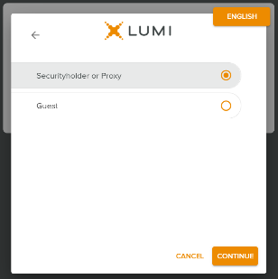

The 1st page of the platform will ask in what capacity you are joining the meeting.

Shareholders or appointed proxies should select

**“Shareholder or Proxyholder”**

Guests should select **“Guest”**

**CREDENTIALS**

**Shareholders/Proxys**

Your username is your **Voting Access Code** and your password is your **Postcode or Country Code**, or, for Non-Australian residents, your **3-letter country code.**

Proxy holders should obtain their log in credentials from the registrar by calling 1300 737 760 (within Australia) or +61 2 9290 9600 (outside Australia)

**Guests**

Please enter your name and email address to be admitted into the meeting.

*Please note, guests will not be able to ask questions or vote at the meeting*.

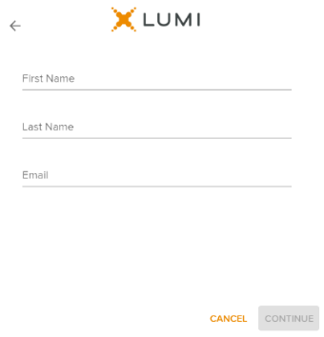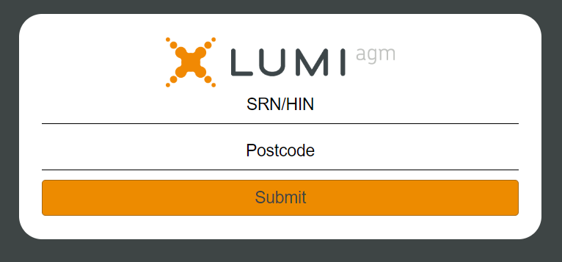

Voting Access Code (VAC)

Postcode or Country Code

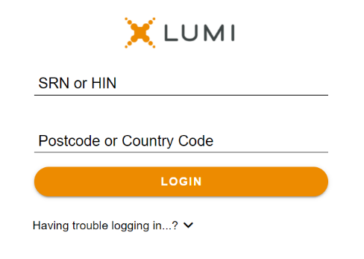

**NAVIGATION**

Once successfully authenticated, the home page will appear. You can view meeting instructions, ask questions and watch the webcast.

If viewing on a computer the webcast will appear at the side automatically once the meeting has started.

On a mobile device, select the broadcast icon at the bottom of the screen to watch the webcast.

During the meeting, mobile users can minimise the webcast at any time by selecting the arrow by the broadcast icon. You will still be able to hear the meeting. Selecting the broadcast icon again will reopen the webcast.

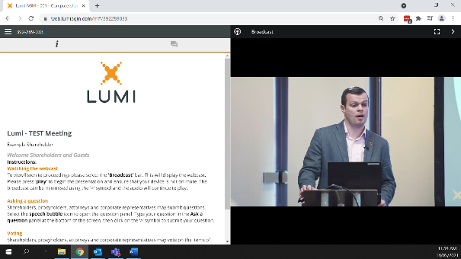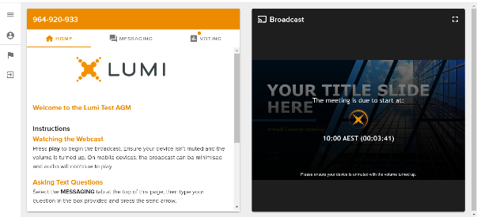

Desktop / Laptop users can watch the webcast full screen, by selecting the full screen icon.

To reduce the webcast to its original size, select the X at the top of the broadcast window.



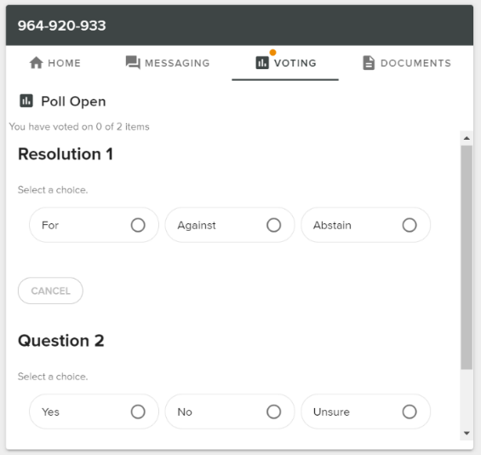**VOTING**

The Chair will open voting on all resolutions at the start of the meeting. Once voting has opened, the voting tab will appear on the navigation bar.

Selecting this tab will open a list of all resolutions and their voting options.

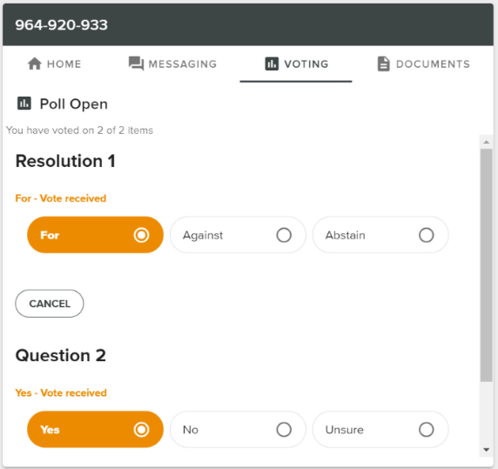

To vote, simply select your voting direction from the options displayed on screen. Your selection will change colour and a confirmation message will appear.

To change your vote, simply select another option. If you wish to cancel your vote, please press cancel.

There is no need to press a submit or send button. Your vote is automatically counted.

Voting can be performed at any time during the meeting until the Chair closes the poll.

**QUESTIONS**

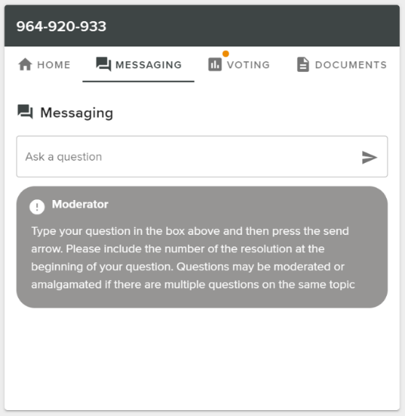

Any shareholder or appointed proxy is eligible to ask questions.

If you would like to ask a question. Select the messaging tab.

Messages can be submitted at any time from the start of the meeting, up until the Chair closes the Q&A session.

Select the “Ask a Question” box and type in your message.

Once you are happy with your message, select the send icon.

Questions sent via the Lumi platform may be moderated before being sent to the Chair. This is to avoid repetition and remove any inappropriate language.



Received

**Meeting ID: 336-339-691**

To login you must have your **Voting Access Code (VAC)** and **Postcode or Country Code**

The website will be open and available for log in from 1:00pm (Melbourne Time), 25th November 2022

**web.lumiagm.com**

